**Name: - Akhand Pratap Singh**

**Sap ID: - 500085043**

**EXPERIMENT-2**

**Title: 2. To understand and apply the concept of Constraints.**

**Objective:** To understand the concept of data constraints that is enforced on data being stored in the table. Focus on Primary Key and the Foreign Key.

**1. Create the tables described below:**

**Table name: CLIENT_MASTER_1**

**Description:** used to store client information.

|  |  |  |  |
| --- | --- | --- | --- |
| **Column name** | **data type** | **Size** | **Constraints** |
| CLIENTNO | Varchar | 6 | Primary key / first letter must start with ‘C’ |
| NAME | Varchar | 20 | Not Null |
| ADDRESS 1 | Varchar | 30 |  |
| ADDRESS 2 | Varchar | 30 |  |
| CITY | Varchar | 15 |  |
| PINCODE | Integer | 8 |  |
| STATE | Varchar | 15 |  |
| BALDUE | Decimal | 10,2 |  |

**Table Name: PRODUCT_MASTER_1 Description:** used to store product information

|  |  |  |  |
| --- | --- | --- | --- |
| **Column name** | **data type** | **Size** | **Attributes** |
| PRODUCTNO | Varchar | 6 | Primary Key/ first letter must start with ‘P’ |
| DESCRIPTION | Varchar | 15 | Not Null |
| PROFITPERCENT | Decimal | 4,2 | Not Null |
| UNIT MEASURE | Varchar | 10 | Not Null |
| QTYONHAND | Integer | 8 | Not Null |
| REORDERL VL | Integer | 8 | Not Null |
| SELLPRICE | Decimal | 8,2 | Not Null |
| COSTPRICE | Decimal | 8,2 | Not Null |

**Table Name: SALESMAN_MASTER _1**

**Description:**  used to store salesman information working for the company.

|  |  |  |  |
| --- | --- | --- | --- |
| **Column name** | **data type** | **Size** | **Attributes** |
| SALESMANNO | Varchar | 6 | Primary Key/ first letter must start with ‘S’ |
| SALESMANNAME | Varchar | 20 | Not Null |
| ADDRESS 1 | Varchar | 30 | Not Null |
| ADDRESS 2 | Varchar | 30 |  |
| CITY | Varchar | 20 |  |
| PINCODE | Integer | 8 |  |
| STATE | Varchar | 20 |  |
| SALAMT | Real | 8,2 | Not Null , Cannot be 0 |
| TGTTOGET | Decimal | 6,2 | Not Null , Cannot be 0 |
| YTDSALES | Double | 6,2 | Not Null |
| REMARKS | Varchar | 60 |  |

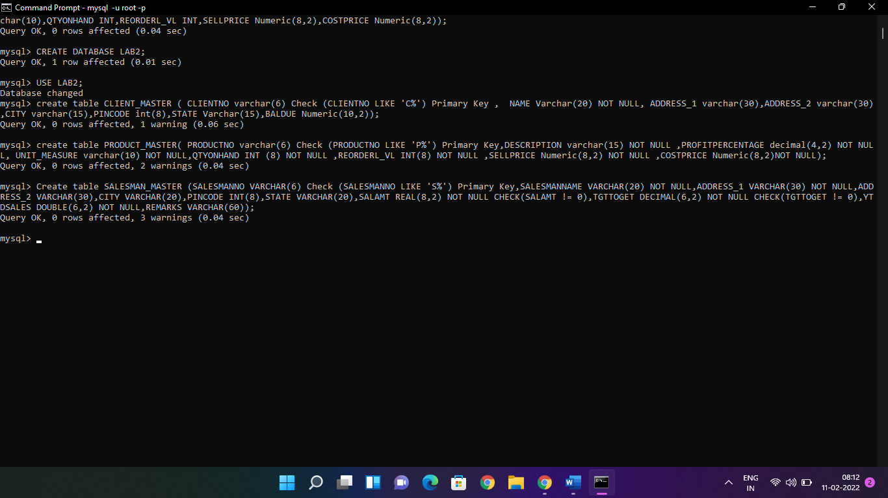

**2. Reinsert the data in these two tables based upon Lab 1.**

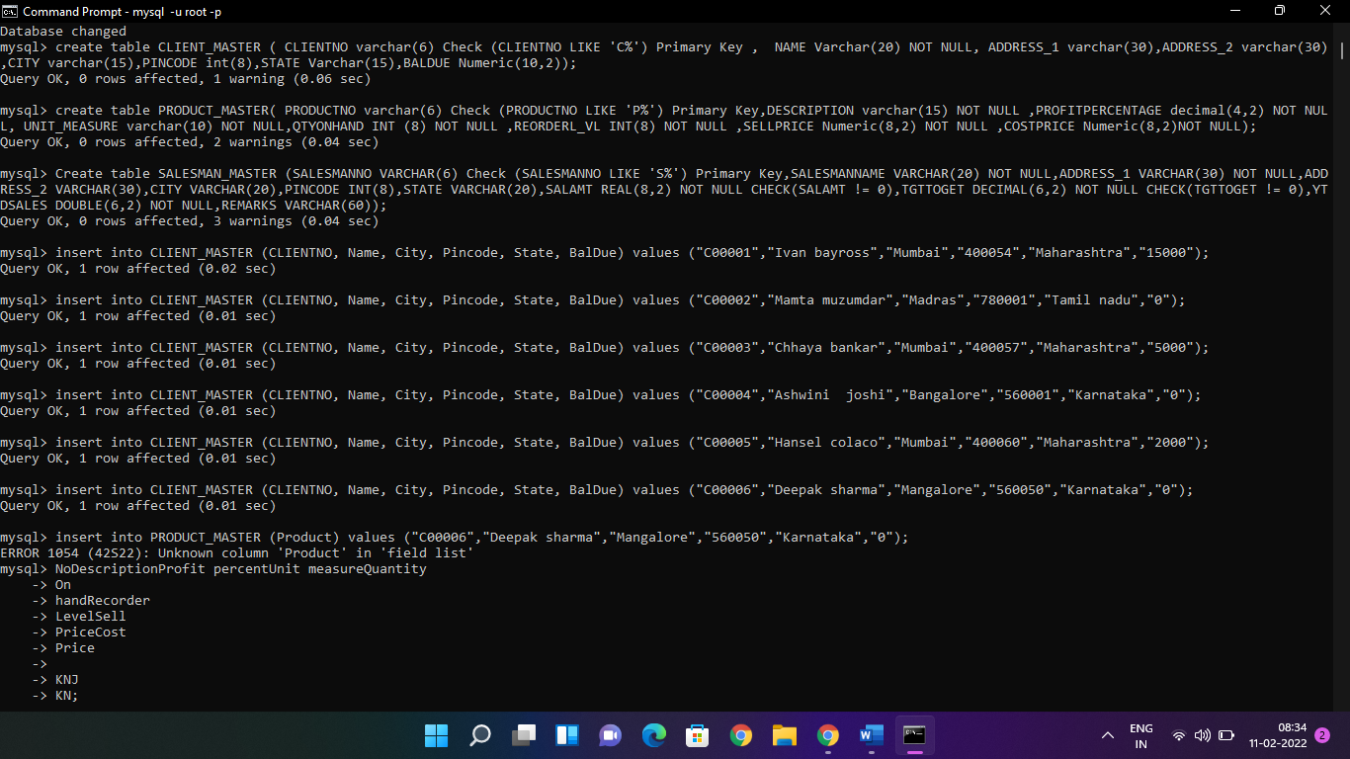

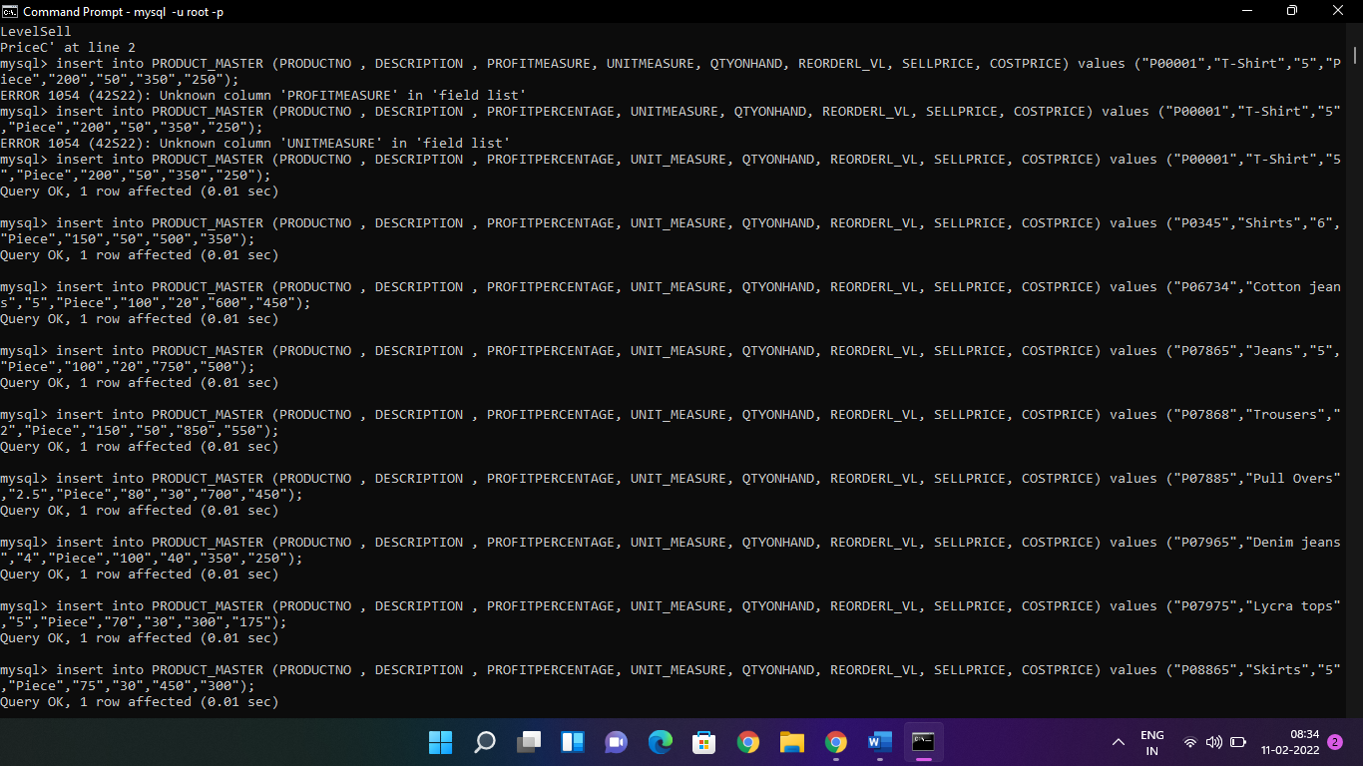

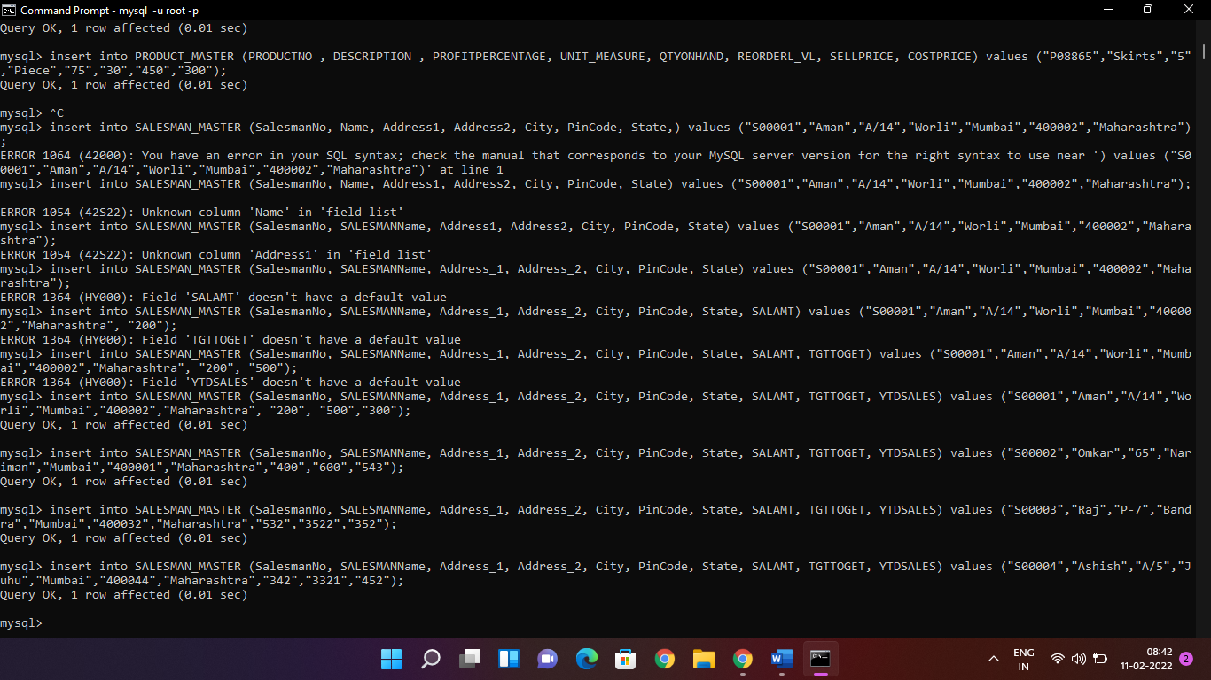

**3. Display the contents of each table.**

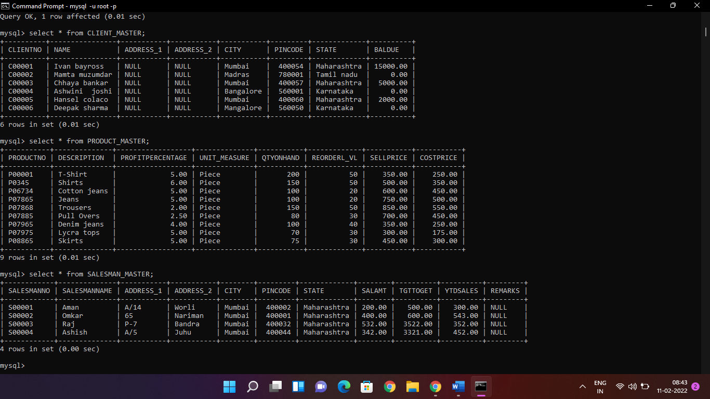

**4. Create table AUTHOR = {Author_ID , Lastname, Firstname, Email, City, Country}**

Where:

Author_ID – text data type, 5 characters, primary key

Lastname – text data type, 15 characters, not null

Firstname – text data type, 15 characters, not null

Email – text data type, 40 characters,

City – text data type, 15 characters,

Country – text data type, 15 characters,

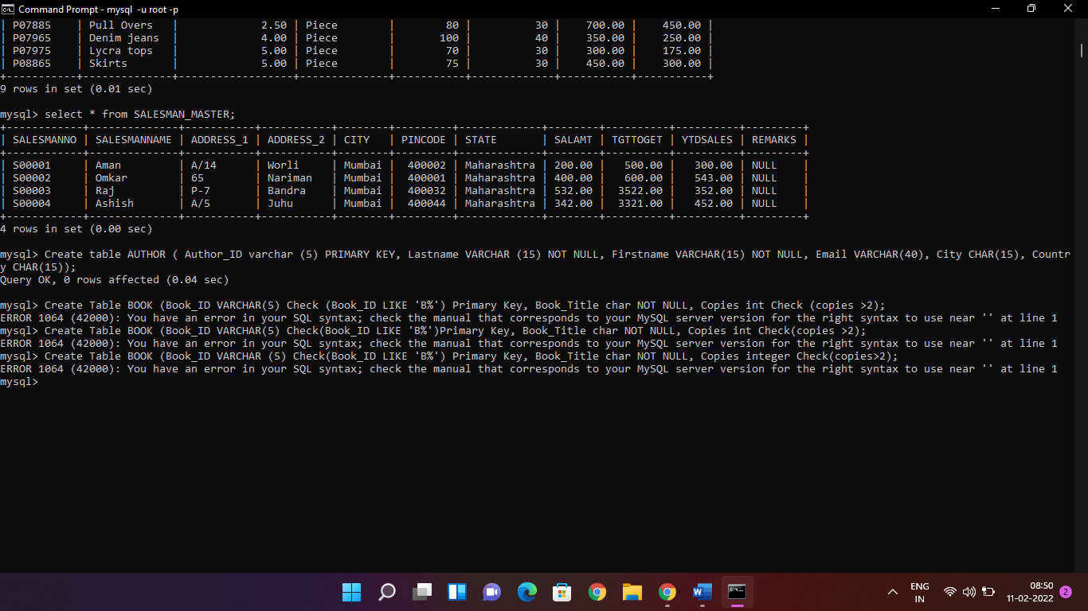

**5. Create Table BOOK={ Book_ID, Book_Title, Copies)**

Where :

Book_ID – text data type, 5 characters Primary Key Start With Character **B**

Book_Title - Text data Type Not Null

Copies- No.of copies Data Type int always greater the 2

**6. Create table AUTHOR_LIST = {Author_ID , Book_ID , Role}**

Where:

Author_ID – text data type, 5 characters, referenced by Author_ID from AUTHOR

table

Book_ID – text data type, 5 characters

Role – text data type, 15 characters

and primary key is: Author_ID, Book_ID

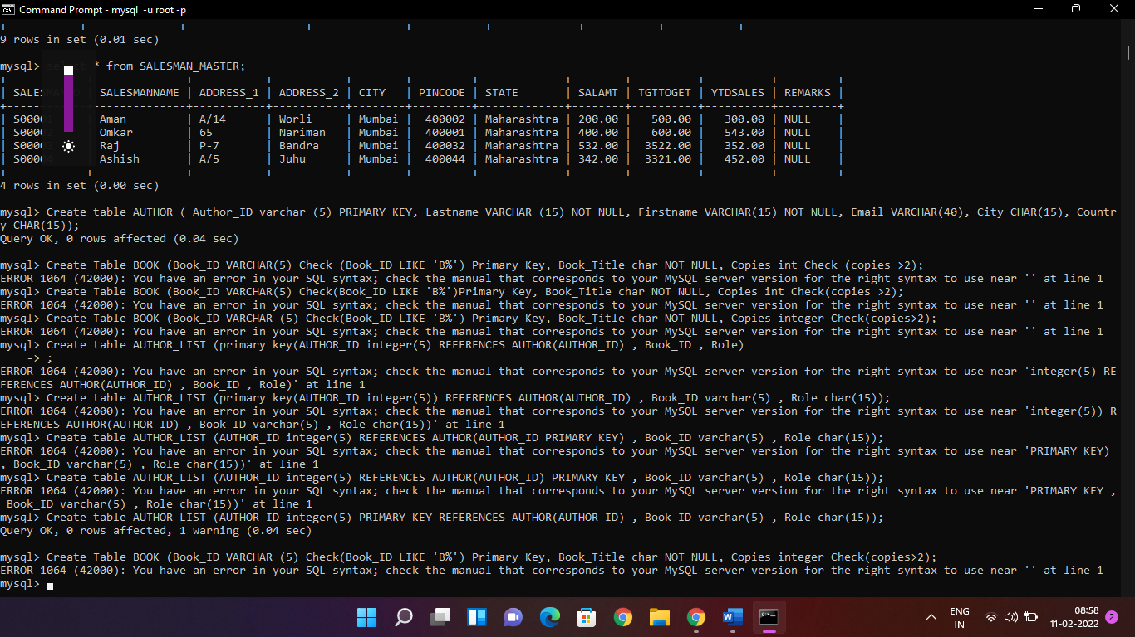

**7. Add four records in each tables AUTHOR, BOOK, BOOK_LIST.**

**8. Alter structure of table AUTHOR_LIST add the field Publisher data type of 30 Character.**

